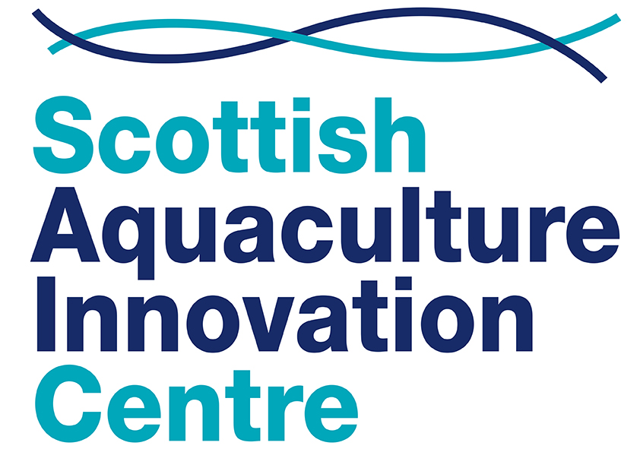

CONFERENCE GRANT APPLICATION

Section 1: Introduction

If you’re a postgraduate student at a Scottish university, and your study is supported by an aquaculture company in Scotland, you could be eligible for a SAIC conference grant.
Grants available
Postgraduate students – If you are presenting an abstract at an aquaculture conference you can apply for a grant.
For conferences within Europe, grants of up to £500 are available.
For conferences outside Europe, you can apply for a grant of up to £800.
Grant money can be used to cover the conference registration fee, with the remainder helping towards travel and subsistence costs.

Terms & Conditions
- All applicants needs to be studying at Scottish HEIs.
- All applicants need to be actively involved in the conference by presenting an abstract or poster
- During the event, you must publicise your attendance on social media
- Within 1 month of attendance:
  - You are required to write a 500 word review of your experience detailing what you learned and how you will apply that to your future studies / employment. Information from this may be used for publicity of SAIC, through the website or social media
  - Provide SAIC with at least 2 photographs taken at the conference which can be used on SAIC website / social media
  - Publicise your attendance and consequent learning on at least one website, print publication relevant to aquaculture, or one social media channel.
- Applications will be reviewed in a timely manner and applicants informed of the outcome. Applications are not guaranteed to be funded as there is only a limited number of places.
- Students will be reimbursed following the event, supply of receipts and delivery of the above criteria.

How to apply
You can apply any time, up to one month before the start date of the conference.
Simply complete the following fields and return your completed form to SAIC mary@scottishaquaculture.com

Section 2: Key contacts
About you
Name
Email
Telephone/mobile
University
Supervisor name
Academic year
Programme of study

Company supporting your research if postgraduate
Company name
Company address
Contact name
Contact email
Company website

Conference details
Conference name
Conference location
Date, month and year
Website
Student registration fee | £
Approx. Travel Costs | £
Total Amount Claiming  Postgrad max £500  Europe; £800 worldwide) | £

Please mark with an X
 | Yes | No
Is this the first time you have attended this event?

Section 2: Abstract

Please paste a copy of your proposed conference abstract or poster here:

Section 3: Supporting information
3.1 Premise of your study
In 300 words or less, please outline:
- The premise of your study
- How it will contribute to the Scottish aquaculture industry
- What you hope to gain from attending this conference.

Premise of study in circa 300 words:

3.2 Promoting the benefits
We want to make as many students aware of the SAIC conference grants scheme as possible. In 100 words or less, please list the ways in which you will help publicise the benefits of a SAIC grant and key learnings from the conference. For example, via Twitter, Facebook, LinkedIn, Instagram, blog or University newsletter.

Promoting the benefits in circa 100 words:

Section 4: Learning outcomes

Please sign below to confirm that you will:
- Provide a copy of your conference registration and payment receipt, as well as receipt(s) for travel
- Write a circa 500-word review of your attendance at the conference, including your key learning goals and outcomes
- Supply a minimum of two photographs taken at the conference (one must include yourself), for promotional use by SAIC
- Publicise your learning – and the SAIC grant – on at least one social media channel.

Name:

Date:

Signature:

How to return your completed form
Please return your completed form to mary@scottishaquaculture.com
We will be in touch as soon as possible to let you know if your conference grant application has been successful.

